
Student name: Home room:
Teacher’s Name: Mathematics class:

St Johns College
DUBBO

Year 8
Term 1 Assessment Task
2013

STAGE 4 MATHEMATICS
(52 marks)

Time allowed: 45 minutes

Directions to Candidates
Calculators may be used in this examination.
Write using black or blue pen only.
Attempt questions in the space provided in this booklet.
All necessary working must be shown and work is to be correctly laid-out.

 | Data analysis and Probability
1. | 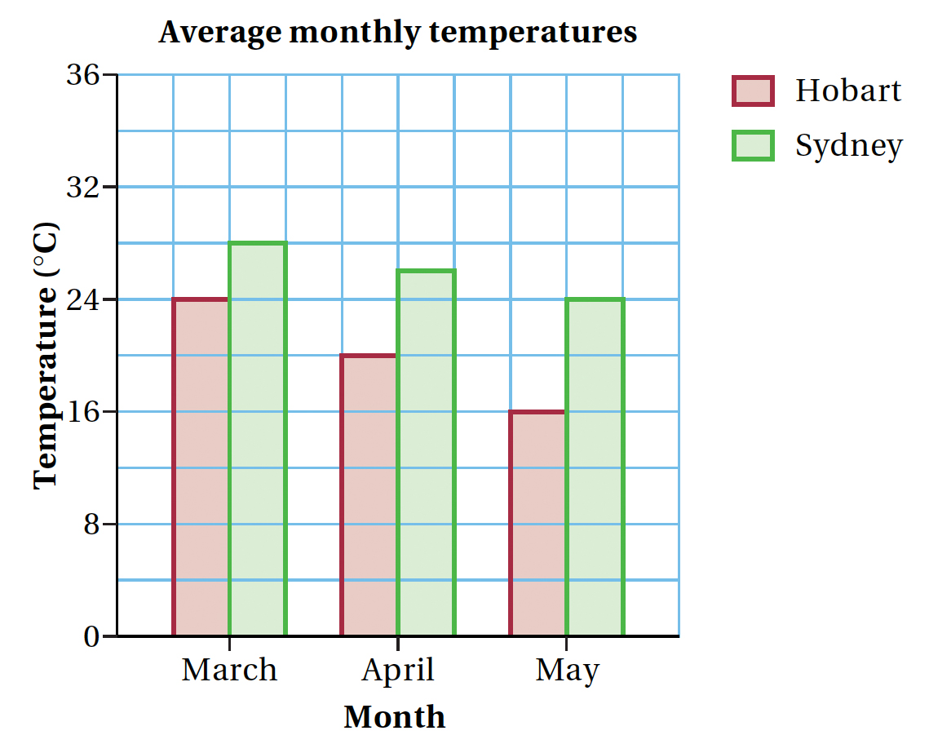 |  |  | (i) Using this graph, state the average monthly temperature in Sydney in March.  Answer: __________ | 1
1. |  |  |  | (ii) What was the difference in average monthly temperatures in Sydney and Hobart in May?  Answer: __________ | 1
2. | 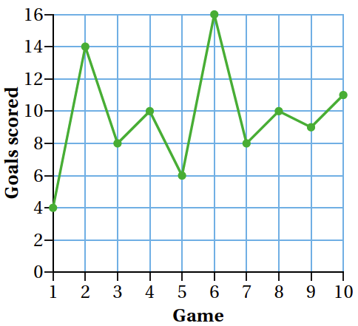 |  | This graph shows the number of goals scored by Sam in 10 basketball games.  (i) What was the lowest number of goals Sam scored in a game?  Answer: _________  (ii) How many goals did Sam score altogether?  Answer: _________
2. |  |  |  |  | 1
2. |  |  |  |  | 1
 | (iii) | What was the average number of goals Sam scored in a game?  Answer: _________ |  |  | 1
 | (iv) | How many goals would he need to score in an 11th game for his average to be exactly 10?  Answer: _________ |  |  | 1
3. | A research company surveyed people to find out the types of television programs watched during the week.  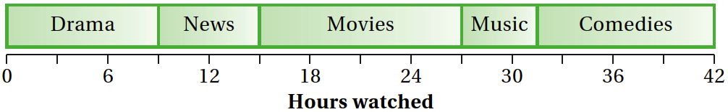  How many more hours of “Comedies” were watched than “News”?  Answer: _________ |  |  |  | 1

4. | 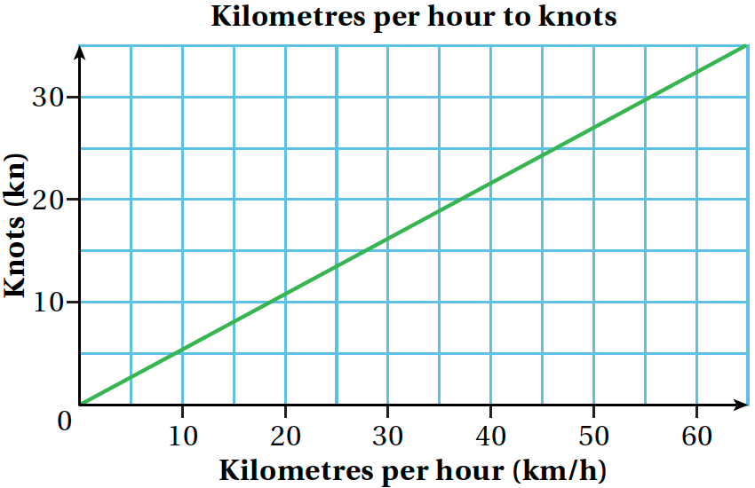 |  |  |  |  |  |  |  | Use the graph on the left to complete the following statements:
4. |  |  |  |  |  |  |  |  | a)  |  |  |  |  | 1
4. |  |  |  |  |  |  |  |  | b) 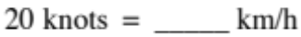 |  |  |  |  | 1
5. | Using the graph on the right, determine the cost of sending a 0.35 kg parcel overseas.  Answer: __________ |  |  |  |  | 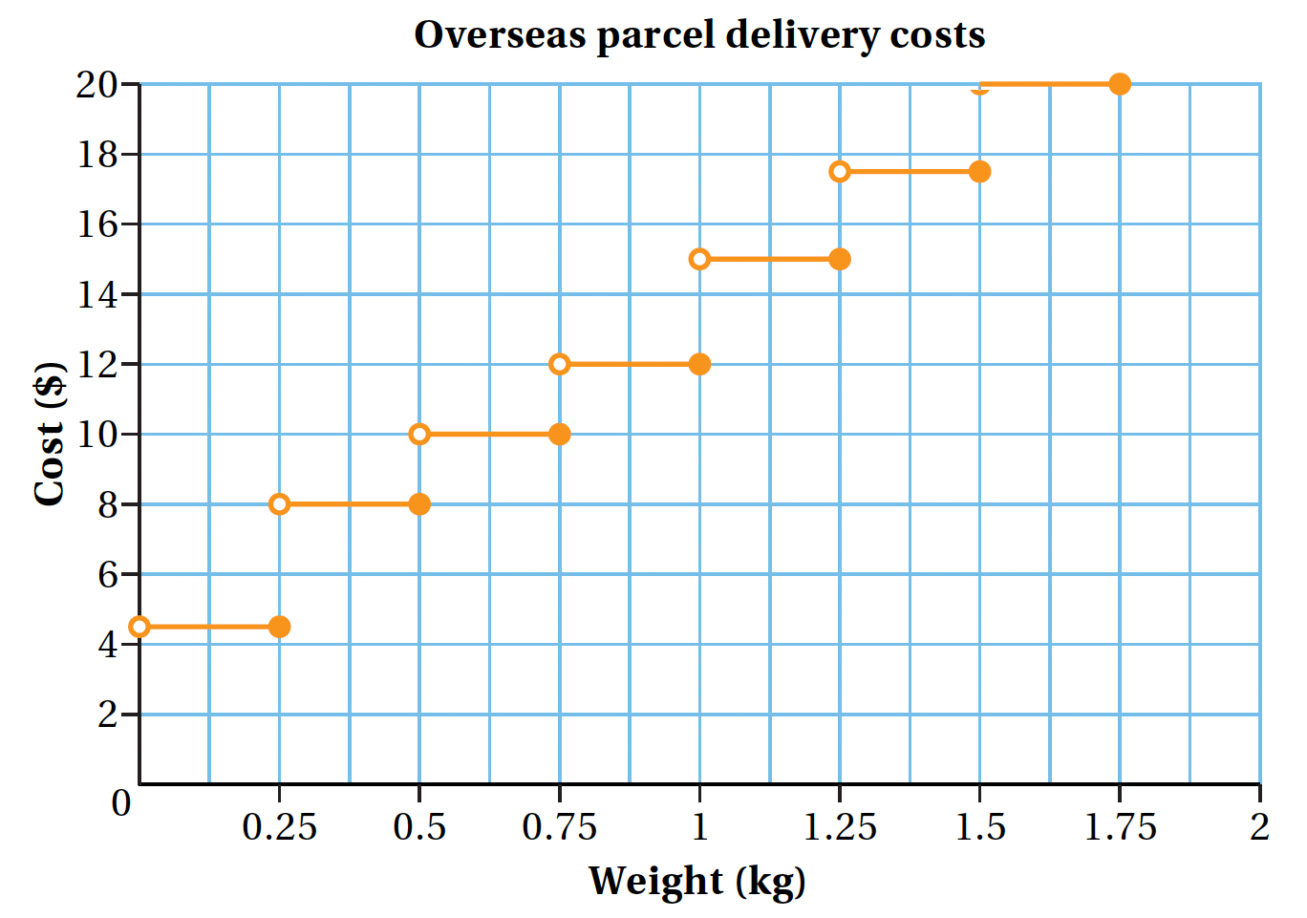 |  |  |  |  |  |  |  | 1
6. | 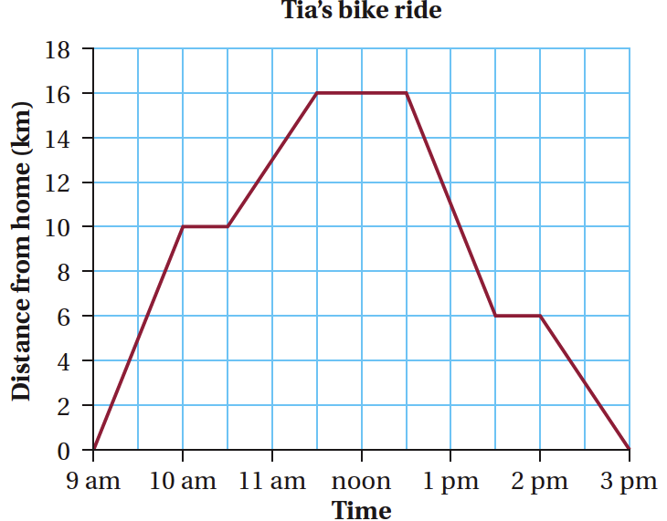 |  |  |  |  |  |  |  | This graph describes Tia’s bike ride. She started her trip from home at 9 am.
6. |  |  |  |  |  |  |  |  | (i) How far did she travel between 11:30 am and 12:30 pm?  Answer: __________ |  |  |  |  | 1
6. |  |  |  |  |  |  |  |  | (ii) What was her average speed between 2 pm and 3 pm?  Answer: __________ |  |  |  |  | 1
7. | 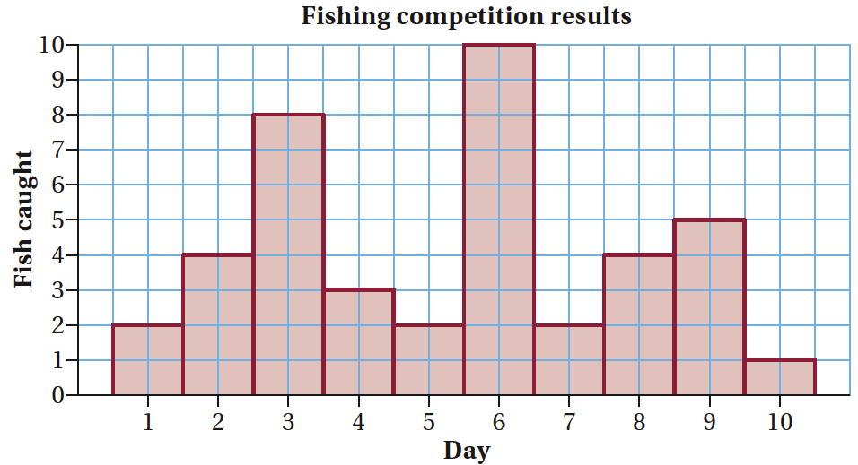 |  |  |  |  |  |  |  |  |  | This histogram shows the number of fish Troy caught in a 10-day competition.
7. |  |  |  |  |  |  |  |  |  |  | (i) On how many days did Troy catch less than 3 fish?  Answer: __________ |  |  | 1
7. | (ii) On what percentage of the days did Troy catch more than 4 fish? |  |  |  |  |  |  |  |  |  |  |  |  | 1
8. | Sandy and Peter travelled between two towns, A and B.
 | 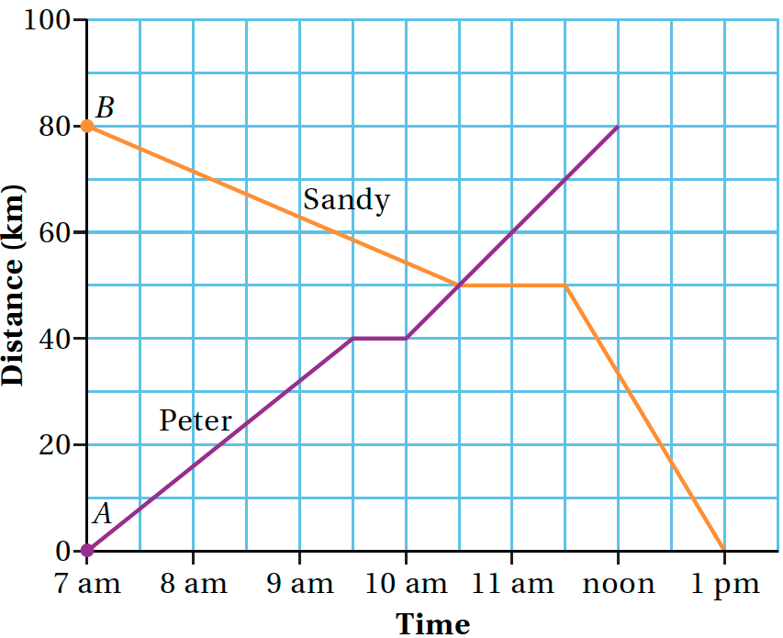 |  |  |  |  |  |  | (i) |  | At what time did Peter and Sandy meet?  Answer: __________ |  |  |  | 1
 |  |  |  |  |  |  |  | (ii) |  | At 11 am, how far was Sandy from town A?  Answer: __________ |  |  |  | 1
9. | 25 randomly selected residents of a retirement village were asked “How many great-grandchildren do you have?” The dot plot on the right was constructed from the data. |  |  |  |  |  |  | 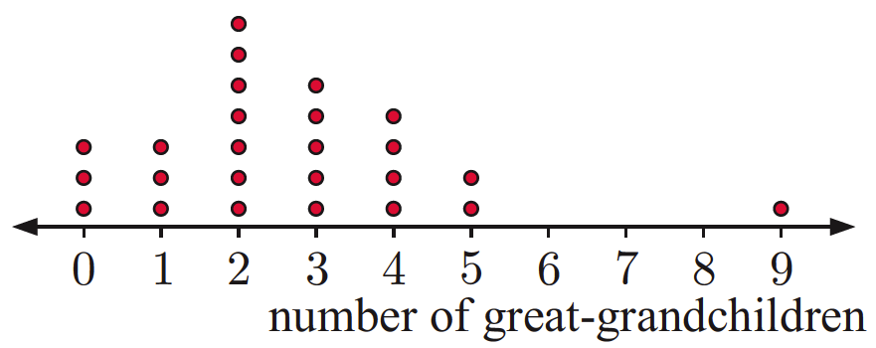
 | (i) | How many residents have 5 great-grandchildren?  Answer: __________ |  |  |  |  |  |  |  |  |  |  |  | 1
 | (ii) | What percentage of residents have more than 3 great-grandchild?  Answer: ________% |  |  |  |  |  |  |  |  |  |  |  | 1
10. | The weights (in kilograms) of 20 students were measured.  88 68 73 81 69 72 74 80 69 63  77 85 72 81 70 79 74 63 75 76  Complete this frequency table for the data. |  |  |  |  |  |  |  |  |  | 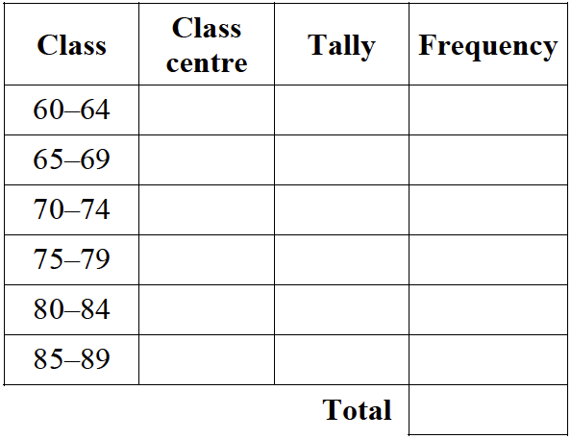 |  |  | 2
11. | For the following stem-and-leaf plot find:
11. | 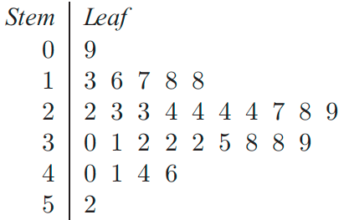 |  |  |  |  |  | (i) |  | Range = _____________ |  |  |  |  | 1
11. |  |  |  |  |  |  | (ii) |  | Mode = ____________ |  |  |  |  | 1
11. |  |  |  |  |  |  | (iii) |  | Median = ____________ |  |  |  |  | 1
11. |  |  |  |  |  |  | (iv) |  | Mean = ____________ |  |  |  |  | 1
12. | 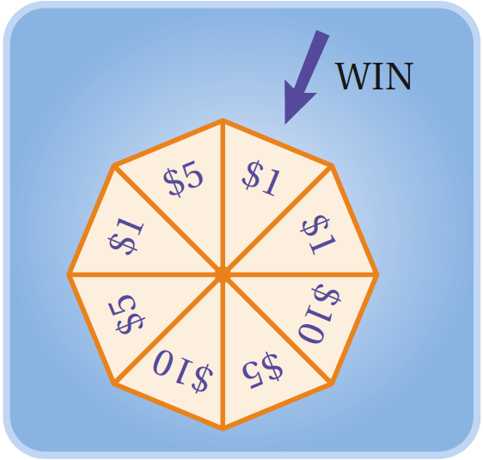 |  |  | This wheel is spun and the player wins the amount that stops at the “WIN” marker. When the wheel is spun at random, what is the probability of winning:  (i) $5? 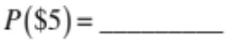  (ii) greater than $1? 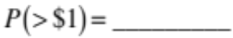
12. |  |  |  |  |  |  |  |  |  |  |  |  |  | 1
12. |  |  |  |  |  |  |  |  |  |  |  |  |  | 1
13. | Six cards with the numbers 10, 9, 8, 7, 6 and 5 are randomly placed face-down on a table.  (i) When a card is turned up, what is the probability of it being a 4?  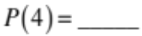  (ii) Jess turned up and removed the 5 card. What is the probability that the next card turned up is 10?  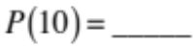 |  |  |  |  |  |  |  |  |  |  | 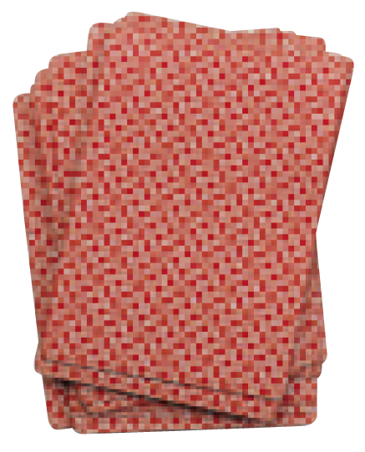 |  | 3
(iii) Starting from the same six cards, Rick turned up and removed 2 cards – 8 and 10.
What is the probability that the next card turned up is 9?
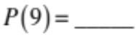
14. | State whether this data is quantitative or categorical:
14. | (i) marks in a test Answer: ________________ |  |  |  |  |  |  |  |  |  |  |  |  | 1
14. | (ii) your favourite song Answer: ________________ |  |  |  |  |  |  |  |  |  |  |  |  | 1
15. | 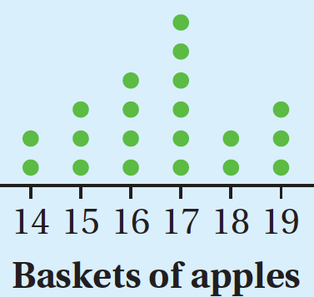 |  | This dot plot shows the number of baskets of apples picked by some workers in a day. If a worker is selected at random, what is the probability that the number of baskets he or she picked was:
15. |  |  | a) |  | 16? Answer:___________ |  |  |  |  |  |  |  |  | 1
15. |  |  | b) |  | 17 or more? Answer:___________ |  |  |  |  |  |  |  |  | 1
16. | An octahedral dice has faces numbered 1 to 8. What is the probability of rolling 5 or less?  Answer:___________ |  |  |  |  |  |  |  |  |  |  |  | 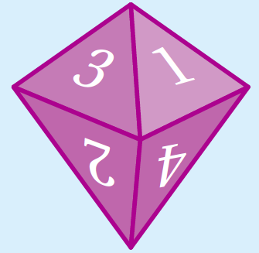 | 1

17. | For each data set below, find the median:
17. | (i) | 1, 1, 1, 2, 3, 3, 3, 4 Answer: _________ | 1
17. | (ii) | 12, 13, 15, 18, 17, 14, 16, 18, 13, 16, 16, 16, 15, 15, 16  Answer: _________ | 1
 | Total Data analysis and Probability: /36

 | Angles and Lines
18. | Find the value of each variable. Give reasons for your answer and show working.
18. | (i) | 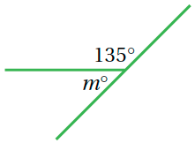 | 2
18. | (ii) | 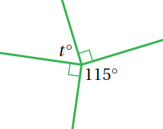 | 2
18. | (iii) | 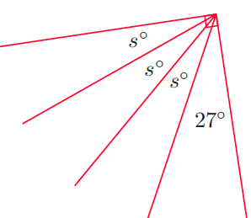 | 2

19. | Find the value of each variable. Give reasons for your answer and show working.
19. | (i) | 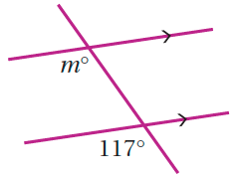 | 2
19. | (ii) | 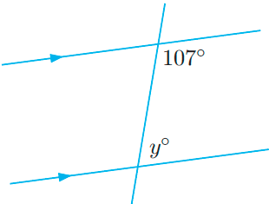 | 2
19. | (iii) | 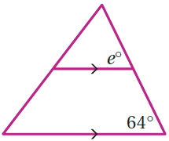 | 2
19. | (iv) | 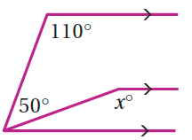 | 2
19. | (v) | 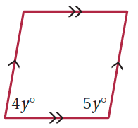 | 2
 | Total Angles and Lines: /16

End of Assessment Task

